The experiences of refugee children may differ from those of other immigrant children due to forced migration, disruptions to education, exposure to violence, and traumatic experiences, which may have long-term effects on their well-being and economic success in the host country.
However, while refugee children may have some experiences in common, they are a highly heterogeneous group. Coming from a variety of different social and political contexts and economic backgrounds, and with varying levels of human capital, many factors are likely to influence the economic trajectories of immigrant and refugee children and youth throughout their adulthood.
We use the Longitudinal Immigrant Database (IMDB), which combines information from immigrants’ landing records with their tax files, to look at the employment incomes of those who arrived in Canada as children from Vietnam and Poland—two large source countries of refugees between 1980 and 1994. We follow their economic trajectories through mid-adulthood, tracking results from ages 25 to 45.
VIETNAM
Predicted employment incomes* by landing category: Vietnam
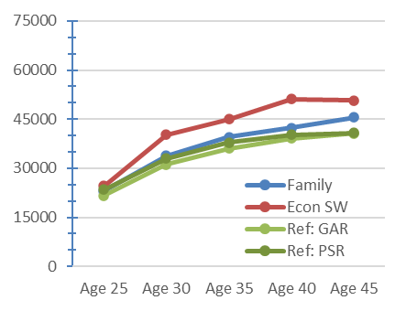
Among those who arrived from Vietnam, the children of skilled worker immigrants have the highest earnings trajectory, although there is little difference between the landing categories at age 25. The predicted average earnings at 25 years old are $21,600 for government-assisted refugees (GARs), $23,400 for privately sponsored refugees (PSRs), and $24,500 for the skilled worker group.
The predicted earnings grow over time for all categories. However, refugees, both GARs and PSRs, have the lowest earnings trajectories. At age 45, the average earnings for GARs and PSRs are under $41,000, while the children of skilled worker immigrants earn nearly $51,000, on average.
POLAND
Predicted employment incomes* by landing category: Poland
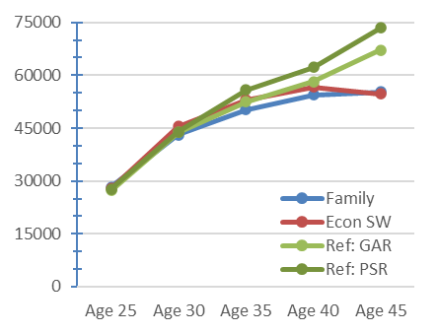
Among those who arrived from Poland, however, we observe a different pattern. There are no discernible differences in young adulthood across the landing categories. For all groups, the predicted incomes at age 25 are about $28,000.
However, childhood refugees of Polish origin tend to increase their earnings substantially, and their rate of earnings growth exceeds those of the children of economic and family class immigrants. For PSRs and GARs from Poland, the predicted earnings at age 45 increase to $73,500 and $67,200, respectively, compared to $55,000 for the children of skilled worker and family class immigrants.
CONCLUSIONS
Refugees are typically seen as uniquely disadvantaged by their circumstances, especially compared to skilled workers and their children. This assumption is reflected in the findings for Vietnamese immigrants, but not for Polish immigrants. These differences in economic outcomes among refugees may point to the negative effects of racialization processes in Canada, or they may reflect important differences in the socioeconomic backgrounds of refugee families, in the context of their departure, and their immigration experiences. Further examination is warranted to explain these differences. Nevertheless, it is clear that landing categories do not represent one type of immigration experience, but rather a wide range of experiences whose effects can be highly variable and context-dependent.

