Jonathan Amoyaw, University of Saskatchewan
Rachel McLay, Dalhousie University
Yoko Yoshida, Dalhousie University

Children and youth represent the majority of the refugee population in Canada. Many of them will spend most of their lives in Canada and will form families here. How well refugee children and youth adapt to the host society is, therefore, a matter of great concern not only for refugees themselves but also for the host society. The economic adaptation of immigrants and their children is vital for their successful settlement and well-being in Canada. While the number of research studies examining the economic outcomes of refugees is growing, it tends to focus on the adult population, leaving gaps in our understanding of the economic activities of refugee children and youth, particularly their long-term trajectories throughout adulthood. Against this backdrop, this report aims to shed light on the long-term economic outcomes of refugee children and youth. Using the Longitudinal Immigration Database (IMDB) and focusing on newcomer children and youth from Poland and Vietnam, two major source countries of refugee youth in the 1980s and 90s, we will examine whether the economic trajectories of refugee children and youth are unique compared to those of other newcomer children. We also consider how other factors, such as gender and source country, affect the outcomes of refugee children and youth.
Existing literature offers various insights regarding the integration process of refugee children and youth. On the one hand, the experiences of refugee children may differ from those of other immigrant children due to forced migration, disruptions to education, exposure to violence, and traumatic experiences, which may have long-term effects on their well-being and also lead to economic disadvantages (Connor, 2010). On the other hand, the literature also showcases resilience among those who have overcome hardships (Pieloch, McCullough, & Marks, 2016; Wilkinson, 2002; 2008). Yet it is unclear whether, and to what extent, the experiences of refugees during childhood impact their long-term economic outcomes. We, therefore, consider entry status/landing category as a factor that may influence the economic trajectories of immigrant and refugee children and youth throughout adulthood.
Several factors are known to affect the employment and earnings trajectories of childhood immigrants and refugees, including the circumstances of their departure, their reception in the host country, and the economic and human capital of their households (Picot, Zhang, & Hou, 2019). While the paths and experiences of each individual or family are unique, economic outcomes of immigrants in Canada have been shown to vary by landing category in important ways. For example, studies on adult immigrants have found that refugees’ employment rates and incomes are often low compared to those of other immigrants, especially economic immigrants (Hou & Bonikowska, 2016). For childhood refugees, their economic trajectories may be disadvantaged by factors such as their parents’ education, language skills, and socioeconomic conditions, as well as by other pre- and post-migration factors, such as dangerous living conditions, traumatic experiences, disruptions to education, and discrimination in the host country (Hou & Bonikowska, 2016; Picot, Zhang, & Hou, 2019). This report examines how the effects of landing category on immigrants’ and refugees’ economic outcomes vary by source country.

The effects of source country: Poland and Vietnam
We look to the examples of Vietnam and Poland, as both were major source countries for immigrants coming to Canada through the 1980s and early 1990s, but with important contextual differences. Vietnamese refugees in this period represented a second wave of refugees following the war. This wave had lower human capital than the first wave and many of them spent extended periods in dangerous conditions before arriving in Canada (Hou, 2017). Moreover, their racialization may contribute to settlement difficulties after their arrival. Polish refugees, on the other hand, were typically highly educated, vocal critics of a political regime, and they received a high degree of support from the existing Polish-Canadian community (Mlynarz, 2007). Coming from central Europe, they were also largely non-racialized, which may ease their integration process and reduce experiences of racial discrimination.
Using the Longitudinal Immigrant Database (IMDB), which combines information from immigrants’ landing records with their tax files, it is possible to study the employment outcomes of immigrants and refugees over time. In this report, we use the IMDB 2016 to look at the employment rates and mean employment incomes of those who arrived in Canada as children, ages 0 to 17, from Vietnam or Poland between 1980 and 1994. Landing categories included in the analysis are family class, skilled workers, and both government-assisted and privately sponsored refugees. We follow economic trajectories through mid-adulthood, tracking results at ages 25, 30, 35, 40, and 45. In what follows, we will first describe the employment rates and mean employment incomes for men and women from the two countries. Thereafter, we will examine the impact of refugee status on these economic outcomes, adjusting for the effects of landing cohort, age at landing, and gender.

Employment rates, ages 25 to 45
Among male childhood immigrants from Vietnam, some differences in employment rates by landing category are evident (Figure 1). Government-assisted refugees show the lowest rates of employment at age 25 (87%), and this disadvantage relative to other categories persists and increases until age 45. Privately sponsored refugees begin at age 25 with similar employment rates as children of skilled workers and family class immigrants, but, over time, this category tends to have slightly lower rates than other immigrants. All landing categories maintain rates close to 90% with the exception of government-assisted refugees, whose rates decline to 85% by age 45.

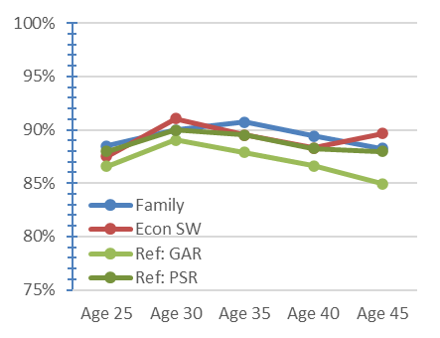
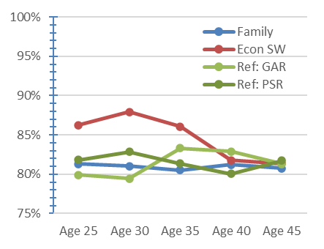

Figure 2: Employment rates for Vietnamese immigrants by landing category: Women

Figure 1: Employment rates for Vietnamese immigrants by landing category: Men

Figure 2 shows differences in the employment rates of women who arrived from Vietnam by landing category. Those whose parents were skilled worker immigrants show much higher employment rates at age 25 (86%) and 30 (88%) compared to those who arrived in other landing categories, whose employment rates range from 79% to 83% at those ages. However, the gaps across categories narrow over time. At age 45, the employment rates of all categories are around 80-83%. Government-assisted refugees have the lowest employment rates at ages 25 and 30, but these improve by age 35, becoming higher than or similar to those of privately sponsored refugees and family class immigrants.
Results for male Polish immigrants, on the other hand, show little difference by landing category, as well as higher employment rates for all categories compared to male Vietnamese immigrants, between ages 25 and 35 (Figure 3). But differences emerge over time, as the employment rates of government-assisted refugees drop to 80% at age 45. Privately sponsored refugees and family class immigrants show similar trajectories, while children of skilled workers maintain the highest employment rate, 85%, at age 45.
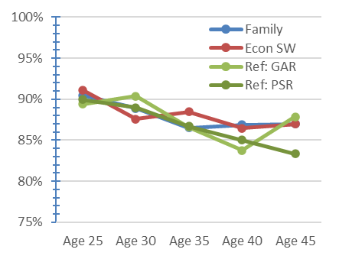
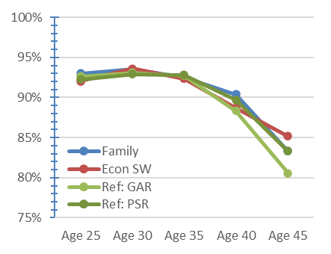

Figure 3: Employment rates for Polish immigrants by landing category: Men

Figure 4: Employment rates for Polish immigrants by landing category: Women

For Polish women, the patterns of employment rates by landing category are similar to those of their male counterparts, though less clear-cut (Figure 4). There are no discernible differences across the landing categories in early adulthood, but gaps emerge by age 40, when the rates of employment among refugees decline relative to the other categories. While rates for government-assisted refugees increase to 88% at age 45, those of privately sponsored refugees decrease further, to 83%. Generally, Polish immigrants show higher overall employment rates compared to Vietnamese immigrants, although they decline slightly at older ages. But differences by landing category are inconsistent, which suggests there could be other factors, such as landing cohort, that may explain these variations.
Overall, these findings suggest that differences between landing categories can affect employment rates at various points across the life course for childhood immigrants, and government-assisted refugees may be particularly disadvantaged compared to other groups. But source country and gender also play an important role in the employment outcomes of childhood immigrants and refugees.

MEAN Employment INCOMES, ages 25 to 45
For yearly employment income, Figure 5 shows that male childhood immigrants from Vietnam have very similar mean earnings across landing categories at age 25, at about $24,000. Over time, those whose parents were skilled workers show the most improvement in average earnings, exceeding $55,000 by age 40. There is little difference, however, between family class immigrants and both categories of refugees, whose mean earnings fall around $45,000 in middle age.
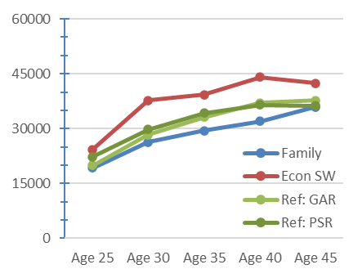
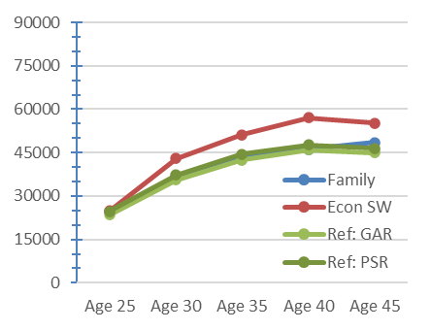

Figure 6: Mean employment incomes for Vietnamese immigrants by landing category: Women

Figure 5: Mean employment incomes for Vietnamese immigrants by landing category: Men

Among Vietnamese women (Figure 6), some differences in the mean employment income based on landing category are observed even at age 25, with children of skilled workers earning the most ($24,300), those in the family class having the lowest average earnings ($19,300), and refugees falling in between. The gap between children of skilled workers and other immigrants and refugees increases by age 30 and persists over time. The mean earnings of both government-assisted and privately sponsored refugees remain slightly higher than those in the family class, but they converge at age 45.
For those who arrived from Poland, however, a very different pattern for the relationship between landing category and earnings emerges. As shown in Figure 7, male Polish immigrants and refugees have similar earnings across landing categories at age 25: around $30,000. But, by age 45, refugees, both privately sponsored and government-assisted, have the highest average incomes, at $85,400 and $76,300, respectively. Those who arrive in the family class have the lowest earnings from ages 30 to 45.

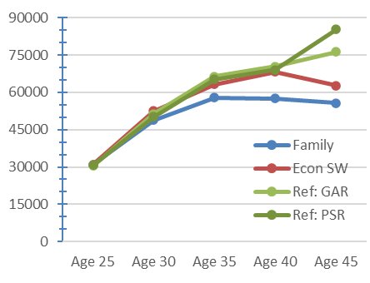
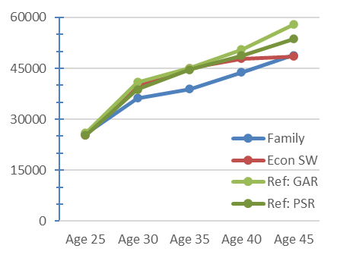

Figure 8: Mean employment incomes for Polish immigrants by landing category: Women

Figure 7: Mean employment incomes for Polish immigrants by landing category: Men

For female immigrants from Poland (Figure 8) as well, differences in mean employment income between landing categories emerge over time. All categories earn a mean income of around $26,000 at age 25, but, by age 45, this increases the most for government-assisted refugees, who earn an average of $57,900, followed by privately sponsored refugees, who earn an average of $53,700. Children of skilled workers show a similar trajectory as refugees until age 40 but, instead of increasing at age 45, their mean income levels off at about $49,000, matching that of family class immigrants.

MEAN EMPLOYMENT INCOMES, CONTROLLING FOR OTHER FACTORS
Other factors besides source country and landing category—such as landing cohort and age at landing—can influence the results. For this reason, multivariate linear regression was used to compare the predicted earnings by source country and landing category, after controlling for landing cohort, age at landing, and gender. This method provides a clearer picture of the differences that may be explained by source country and landing category.
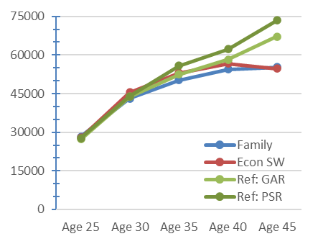
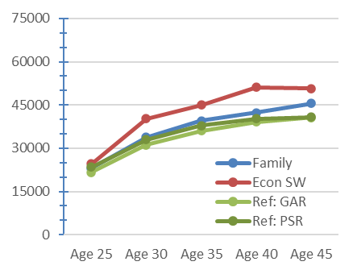
Figure 9: Mean employment incomes for Vietnamese immigrants by landing category

Figure 10: Mean employment incomes for Polish immigrants by landing category

A few key findings are evident from the analysis. First, childhood immigrants’ landing category makes a difference in their earnings throughout adulthood. In the Vietnamese group (Figure 9), children of skilled worker immigrants have a higher earnings trajectory compared to those in the family class and those who arrived as refugees. Although there is little difference between categories at age 25, gaps in earnings are evident by age 30 and persist at age 45. Those who arrived as refugees, whether government-assisted or privately sponsored, have the lowest earnings trajectories. In the Polish group (Figure 10), on the other hand, childhood refugees tend to increase their earnings in their 40s, while earnings among children of other immigrant parents begin to level off in middle age.
Remarkably, the earnings trajectories among refugees are quite different between Vietnamese and Polish groups. For Vietnamese refugees, the predicted average earnings at 25 years old are around $21,600 for government-assisted refugees and $23,400 for privately sponsored refugees, and these gradually increase to around $40,000 for both groups at age 40. Polish refugee children, on the other hand, have higher earnings at 25 years old (about $27,500 for both government-assisted and privately sponsored refugees) compared to Vietnamese, and these earnings continue to increase substantially throughout their 40s, reaching $67,200 for government-assisted refugees and $73,500 for privately sponsored refugees.
CONCLUSION
This report provides an overview of the economic trajectories of Vietnamese and Polish refugee and immigrant children and youth who arrived in Canada in the 1980s and 90s, tracking their employment rates and earnings from ages 25 to 45. Our analysis highlights unique patterns across landing categories but also between the source countries. Refugees are typically seen as disadvantaged due to the context of their departure, which is often characterized by persecution, exposure to violence, traumatic experiences, and other hardships. These adverse experiences among refugee children may well account for the gaps in economic trajectories of some groups, but not all. Our findings for Vietnamese newcomer children indicate that refugee status was associated with long-term economic disadvantage relative to their counterparts who came as non-refugee children. However, this was not the case for Polish immigrants. The economic trajectories of refugee children from Poland were similar or even improved compared to those of non-refugee immigrant children. This offers some evidence for the resilience of refugee children. However, our findings underscore complexities in the experiences of childhood refugees that have differential impact on their long-term economic trajectories.
The differences in economic outcomes between refugees from Vietnam and Poland may signal the negative effects of racialization processes in Canada, but it could also be explained by differences in the socioeconomic backgrounds of refugee families between the two countries, the context of their departure and immigration experiences, as well as the existence and support of ethnic communities in the country. Further examination is warranted to explain these differences and to shed light on the factors that promote resilience among refugee children. A more detailed examination of the impact of refugee children’s socioeconomic background (e.g. parents’ occupation and household income) and educational achievements would be insightful. Our findings, which drew systematic comparisons between newcomer children from two countries with a comprehensive coverage of the refugee population, offer solid grounds to launch further investigations.
Although refugees are admitted on humanitarian grounds, our findings also suggest that they are generally not an economic burden. With the necessary support, they can contribute to Canada’s economy much like other immigrants over time. Individual, family, and community-based interventions aimed at improving the well-being of refugee children are, therefore, critical. The focus of these initiatives should be on empowering refugee children to have a positive outlook, providing social support for their families and fostering family connectedness and a strong sense of belonging to their communities (Pieloch, McCullough, & Marks, 2016). Educators and community support groups should also take into account the local and political climates surrounding the departure and reception of refugees and their children, which have implications for their well-being. Moreover, some nuance is called for when speaking of the relationship between landing category and economic outcomes. These categories do not represent a single type of immigration experience, but rather a wide range of experiences whose effects can be highly variable and context-dependent.

References
Connor, P. (2010). Explaining the refugee gap: Economic outcomes of refugees versus other immigrants. Journal of Refugee Studies, 23(3), 377–397. https://doi.org/10.1093/jrs/feq025
Hou, F., & Bonikowska, A. (2016). Educational and labour market outcomes of childhood immigrants by admission class. Analytical Studies Branch Research Paper Series, 11F0019M No. 377. Retrieved from https://www150.statcan.gc.ca/n1/en/pub/11f0019m/11f0019m2016377-eng.pdf?st=eDfp9nVK
Hou, F. (2017). The resettlement of Vietnamese refugees across Canada over three decades. WIDER Working Paper 2017/188. Retrieved from https://www.wider.unu.edu/sites/default/files/Publications/Working-paper/PDF/wp2017-188.pdf
Mlynarz, M. (2007). "It's our patriotic duty to help them': The socio-cultural and economic impact of the 'solidarity wave' on Canadian and Polish-Canadian society in the early 1980s. Past Imperfect, 13, 56-83. https://doi.org/10.21971/P7MW2M
Picot, G., Zhang, Y., & Hou, F. (2019). Labour market outcomes among refugees to Canada. Analytical Studies Branch Research Paper Series, 11F0019M No. 419. Retrieved from http://publications.gc.ca/collections/collection_2019/statcan/11f0019m/11f0019m2019007-eng.pdf
Pieloch, K. A., McCullough, M. B., & Marks, A. K. (2016). Resilience of children with refugee statuses: A research review. Canadian Psychology, 57(4), 330–339. http://dx.doi.org/10.1037/cap0000073
Wilkinson, L. (2002). Factors influencing the academic success of refugee youth in Canada. Journal of youth studies, 5(2), 173-193.
Wilkinson, L. (2008). Labor market transitions of immigrant-born, refugee-born, and Canadian-born youth. Canadian Review of Sociology, 45(2), 151-176.

